IMPLEMENTATION OF NDN ROUTING

Tody Ariefianto Wibowo School of Electrical Engineering Telkom University

Bandung, Indonesia [ariefianto@telkomuniversity.ac.id](mailto:ariefianto@telkomuniversity.ac.id)

Leanna Vidya Yovita School of Electrical Engineering

Telkom University Bandung, Indonesia

[leanna@telkomuniversity.ac.id](mailto:leanna@telkomuniversity.ac.id)

Ade Aditya Ramadha School of Electrical Engineering

Telkom University Bandung, Indonesia

***Abstract*— Named Data Network (NDN) brings a new paradigm and provides a fundamental change in the implementation of data communication in the future internet. In NDN, the delivery of information is more dynamic, not only the role of the client and server, but also the participation of all components in the network. Routing is one of the important factors in the message delivery mechanism on NDN in determining the best path for transmitting information. Scalability in routing, in order to serve the increasing number of users and content, is a problem that arises with the increasing number of entities on the internet. NDN requires a routing protocol that is scalable, robust yet highly efficient in content delivery. This study aims to implement the implementation of a prototype NDN router on a simple NDN network on a lab scale. Based on previous research [1], [2] that NDN network will have better performance than IP network. So it is considered important to observe how far the NDN router can provide increased performance for data communication on the network. The observed performance is cache hit ratio, CPU usage, throughput and RTT, with scenarios of changing prefix length and content size on the network using static NDN routing. From the results of the study, it was found that the change in prefix length did not really affect the CHR, but it did affect the CPU Usage. Changes in data size don't really affect CHR, but have a big impact on CPU Usage, RTT, and Throughput.**

***Keywords—NDN, caching, replacement, performance, virtual node***

1. INTRODUCTION

Named Data Networking was first proposed by Van Jacobson [3], [4] which is intended to deal with critical problems related to the increasing use of the internet for end- to-end connections to receive and transmit content/data, instead of directly searching for the content/data itself. . In this case, it means that in the context of searching for content/data on an IP-based network, it actually focuses on establishing a connection, not looking for content/data. This is said by Van Jacobson a "misconduct of internet's behavior", which is predicted to cause the collapse of the internet network in the future in the near future, due to the enormous traffic generation in the above communication process.

Currently routing on IP is one technique that can be said to have been established, this is evidenced by the connection of all internet entities in the world. We can easily connect from one entity to another, even though geographically they may be very far apart, as long as both are part of the internet network. However, the "steady" condition was described by the Internet Architecture Board (IAB), a committee as a joint of the Internet Engineering Task Force (IETF) and the Internet Society (ISOC), in a 2007 report [5], that routing on

the internet has problems with scalability. . Then what about routing on NDN?

Basically the routing mechanism that is widely used in IP networks is proactive routing. This routing has the ability to periodically update links whether or not there are packets to be sent. Routing on NDN that has been proposed in previous studies such as OSPFN [6], and NLSR [7] is also a reactive routing protocol. So it is very important to be able to observe the routing mechanism as an opportunity for research on reactive routing protocols on NDN.

The need to implement an NDN network is getting higher. This is in order to prove the concept of NDN on a real data communication network. By building an NDN network implementation, we will be getting closer to prototyping NDN hardware.

1. RELATED WORKS
2. *Component of NDN’s nodes*

In NDN, there are two types of packets circulating on the network, namely Interest Packet and Data Packet [3]. Interest Packet contains information related to the content requested by the consumer and Data packet is a packet that contains content data according to the interest information sent from the producer (origin of a content) or other node (also called router) requested by the consumer (entity requesting an content) in response to the previously sent Interest packet.

The Content Name section of the Interest Packet and Data packet as well as the Nonce is a mandatory element, while the Selector section is an optional section that is used to select what content consumers want. Nonce contains 4 octet byte string which is generated randomly [8].

There are three main parts of the NDN node, which can be seen in Figure II.2, seen from the different functions (i) the Content Store (CS) section where the content that has been sent for the previous request is temporarily stored; (ii) Pending Interest Table (PIT), records/records of interests that have been served by the router, but the requested content has not been sent; (iii) Forward Information Base (FIB), records/records related to the position path of content on the network.SYSTEM MODEL

Application held using AAEON FWS-2365 , which is a white box with various application Like uCPE and SD- WAN. Device this powered by an Intel Atom C3000 processor with 4-16 cores supporting processors. Features _ including :

* + Intel® Atom® C3000 Series . Processor
  + 10/100/1000Base-TX Ethernet x 6
  + Supports 1 pair bypass (LAN 3~4)
  + Up to 4 x 10G SFP+ Ports (C3558 only supports 2 ports)
  + DDR4 SODIMM x 2 . sockets
  + SATA III x 2” ports
  + Built-in 16GB eMMC, up to 128GB
  + card slot x 1 (Half size, PCIe), Mini card slot x 1 (Full size, PCIe + USB2.0) with SIM slot
  + Key M.2 B 3052 x 1 (USB3.0) with SIM slot
  + USB3.0 TypeA x 2 ports (1 Port only supports USB2.0 signal)

1. *Testing Scenarios and Parameters*
2. Performance testing against changes in prefi length

* CS size: 30 packs
* Interest: (Zipf, exp factor = 0.8, flattened factor = 3, 500 int/s)
* Prefix in producer Variable slash length : 4,8,16 ,32

1. Performance test against Packet length

* CS size: 30 packs
* Interest: (Zipf, exp factor = 0.8, flattened factor = 3, 1000 int/s)
* Content pack size with variable size: 1kb,2kb,4kb

1. PERFORMANCE EVALUATIONS

*A. Prefix length change scenario*

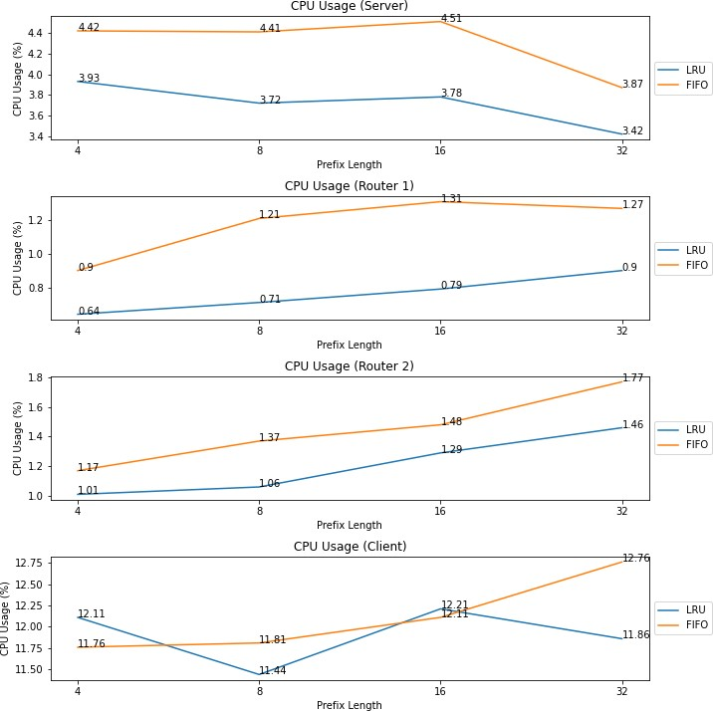

On routers, the longer the prefix length, the greater the CPU load. This is because the load of reading the name of the content is getting bigger. In this scenario, a request speed of 500 int/s is used. For consumers, CPU usage also continues to increase because consumers need to process requests with long enough names. Different things happen to producers. At an interest of 500 int/s, the router can still handle requests. So this request has not yet reached the producer.

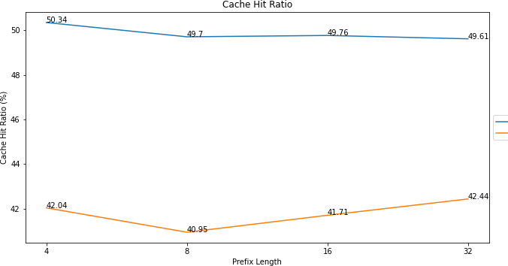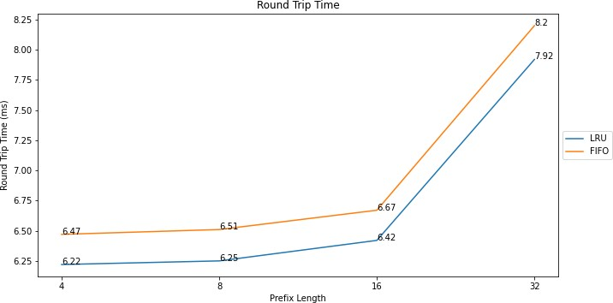1.

In the scenario of changing the length of the prefix length, it does not affect the cache hit ratio much.

The RTT gets bigger for bigger prefix lengths, and increases significantly at 32 prefix lengths.

As RTT increases, throughput decreases at prefix length 32.

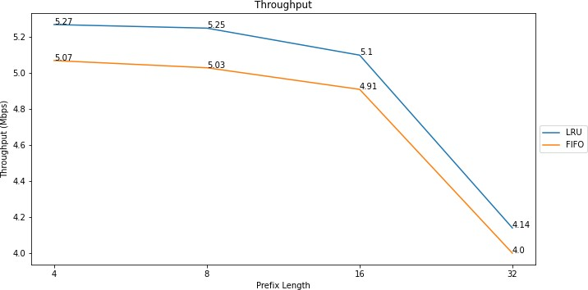.

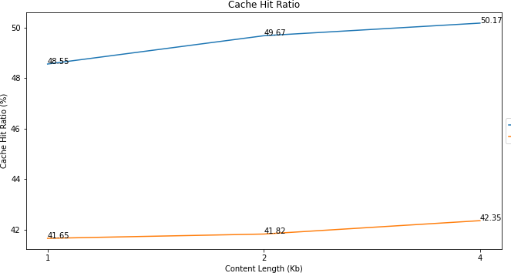

In the scenario of changing the packet size from 1kB, 2kB and 4 KB, it is seen that the cache hit ratio is not too affected. Because the size of the CS is in packets, this change in packet size has no effect on the cache hit ratio.

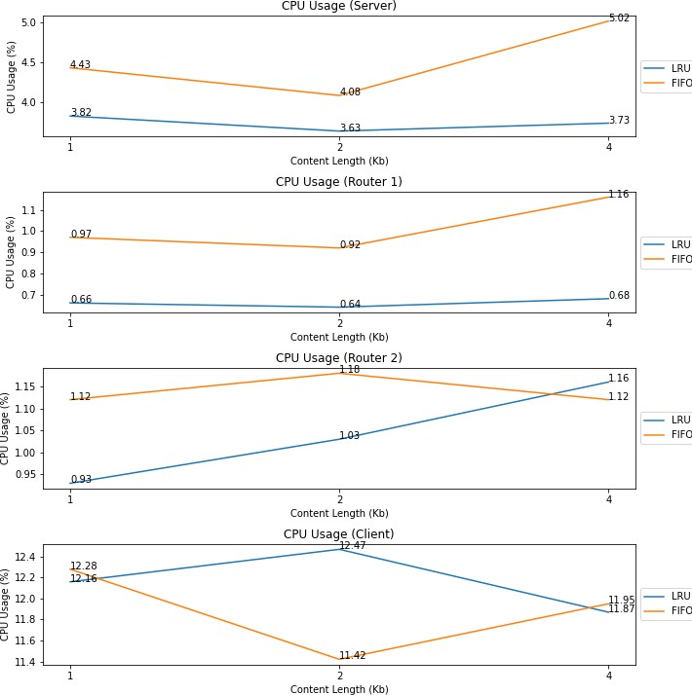

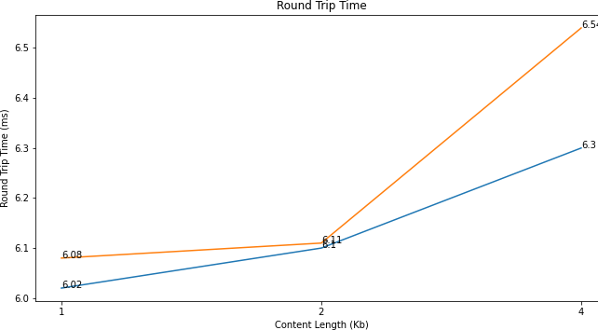In general, for both producers and routers, the increase in content size also affects CPU usage. This is because both producers and routers have to process longer packets. For the consumer, the longer the packet, the lower the CPU usage if using LRU.

The RTT gets bigger for longer packages. This is due to the longer processing time for all content.

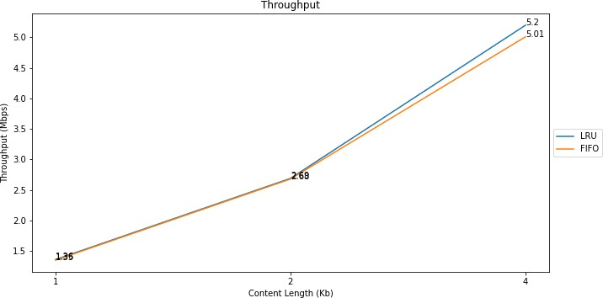

Throughput also increases with increasing packet size. This is because the greater the content that goes in and out of the network and increases the throughput per second.

Conclusions

1. NDN has been successfully implemented using FWS- 2365, where all node working mechanisms are in accordance with NDN
2. Changes in prefix length don't really affect the CHR, but it does affect CPU usage
3. Changes in data size don't really affect CHR, but have a big impact on CPU Usage, RTT, and Throughput.

References

1. V. Jacobson, D. K. Smetters, J. D. Thornton, M. F. Plass, N. H. Briggs, and R. L. Braynard, “Networking named content,” in Proceedings of the 5th international conference on Emerging networking experiments and technologies - CoNEXT ’09, 2009, p. 1.
2. L. Zhang et al., “Named data networking,” ACM SIGCOMM Comput. Commun. Rev., vol. 44, no. 3, pp. 66–73, Jul. 2014.
3. D. Meyer, “RFC 4984 - Report from the IAB Workshop on Routing and Addressing,” 2007.
4. L. Wang and A. K. M. M. Hoque, “OSPFN : An OSPF Based Routing Protocol for Named Data Networking,” pp. 1–15, 2012.
5. V. Lehman, M. M. Hoque, Y. Yu, L. Wang, B. Zhang, and L. Zhang, “A Secure Link State Routing Protocol for NDN,” 2016.
6. W. T. Ariefianto and N. R. Syambas, “Routing in NDN network: A survey and future perspectives,” in 2017 11th International Conference on Telecommunication Systems Services and Applications (TSSA), 2017, pp. 1–6.
7. T. A. Wibowo, N. R. Syambas, and Hendrawan, “Overhead of Named Data Networking Routing Protocol,” in 2018 12th International Conference on Telecommunication Systems Services and Applications (TSSA), 2018, pp. 1–5.
8. C. Yi, A. Afanasyev, I. Moiseenko, L. Wang, B. Zhang, and L. Zhang, “A case for stateful forwarding plane,” Comput. Commun., vol. 36, no. 7, pp. 779–791, Apr. 2013.
9. C. Yi, J. Abraham, A. Afanasyev, L. Wang, B. Zhang, and L. Zhang, “On the role of routing in named data networking,” in Proceedings of the 1st international conference on Information-centric networking - INC ’14, 2014, pp. 27–36.
10. T. A. Wibowo, N. R. Syambas, and Hendrawan, “Named Data Network ( NDN ) Scalability Problem,” in IEEE Asia Pacific Conference on Wireless and Mobile (APWiMob), 2019.